**CMPE-277: Smartphone application Development**

**Assignment 2 – Implicit Intents**

**Submitted to:** Prof. Chandrasekar Vuppalapati

**Submitted by:** Anvit Saxena (SJSU ID: 010953436)



In this assignment, we demonstrate the concept of Implicit Intents. I have created an Android application that explains the usage of Implicit Intents with ACTION_DIAL and ACTION_VIEW. Following are the steps along with screenshots that explains in detail:

**Step 1:** The application “Implicit Intents” as shown below has two fields, one to enter URL and other to enter phone number.

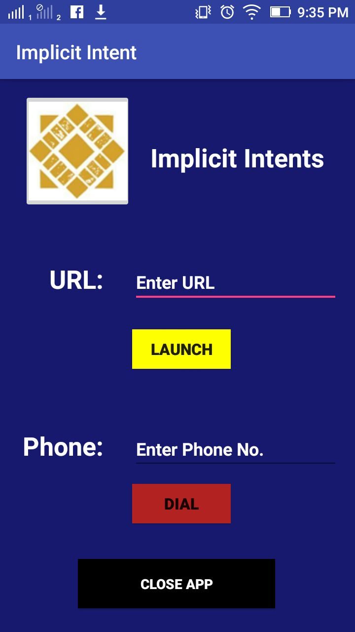

**Step 2:** As we enter a URL and click on “Launch” button a pop up screen comes asking us to choose which browser we need to use for opening the URL. And as shown in the below screenshot we select any browser and the link opens up.

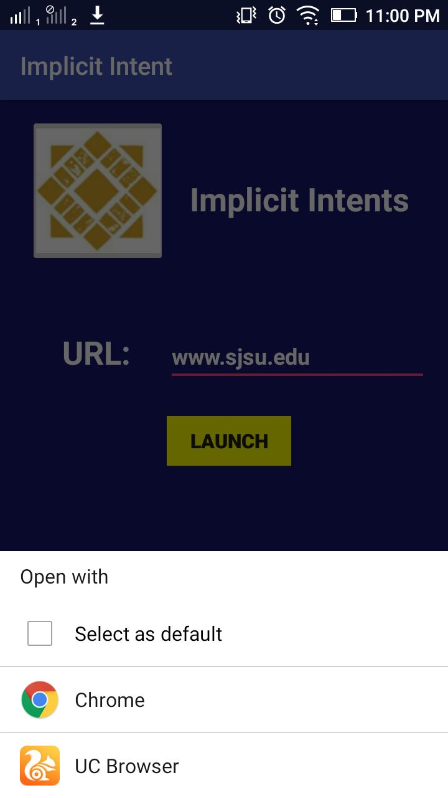



**Step 3:** Now we enter phone number in the text field and then click on “Dial” button. Once we dial, a pop up screen appears to choose which application we need to use to dial a call as shown in the below screenshot. Once selected the dial pad appears having the phone number we entered in the text field.

